**World Health Expenditure Prediction with Artificial Intelligence and Generative AI**

**1T. Yu, 1D. Bera, 2A. Maazallahi, 3R. Dsouza, 3F. Pali, 1W. S. Liu, 4P. Norouzzadeh, 5E. Snir, 1B. Rahmani**

**1Sain Louis University, School of Medicine HCOR, Saint Louis, MO**

**2University of Tehran, Computer Science Department, Tehran, Iran**

**3Saint Louis University, Computer Science Department, Saint Louis, MO**

**4Saint Louis University, Professional Studies Department, Saint Louis, MO**

**5Washington University in Saint Louis, Business School, Saint Louis, MO**

**Abstract**

Healthcare expenditure continues to rise globally, creating significant economic challenges, particularly for low- and middle-income nations. Accurate predictions, efficient resource allocation, and equitable policy designs are critical for addressing these challenges. This study explores the potential of integrating generative AI with traditional econometric and machine learning models to analyze and predict healthcare expenditure trends. Using data from the World Bank and WHO, methods such as Generative Adversarial Networks (GANs), clustering, support vector machines (SVM), and autoregressive integrated moving average (ARIMA) models are applied to uncover patterns, simulate scenarios, and address disparities in spending. The generative AI approach augments incomplete datasets, identifies anomalies, and provides personalized policy recommendations, ensuring inclusivity and equity in global health resource planning. Results demonstrate improved accuracy in forecasting and deeper insights into expenditure trends, particularly for underrepresented regions. This study highlights generative AI as a transformative tool in advancing equitable, data-driven solutions for global healthcare expenditure management.

**1. Introduction**

**1.1 Global Trends in Health**

After a huge elevation of 7.4% in 2022 and 10.7% in 2023, it is estimated that the global trend in healthcare expenditure will reduce to an average of 9.9% in 2024 [1]. While this projected downfall is a positive aspect, the medical cost is still burdensome and has gradually increased globally due to various factors including GDP, aging populations, and healthcare policies [2], [3]. Estimates of changes in global health R&D expenditures are crucial to improving and setting boundaries for health research policies [4], [5]. However, comparing this information among different countries can be a challenging task as there is a gap in measuring the data per region [4].

Over the last couple of decades, healthcare spending has nearly doubled in many high-income countries, followed by projections that global spending could reach $15 trillion by 2050 [2], [3]. In 2021, the healthcare spending in the U.S. was nearly double than those of other high-income countries and significantly higher costs for inpatient, outpatient, and administrative services [6]. Additionally, it is estimated that U.S. per capita spending, an annual average rate of 5.0%, on health will outpace the GDP from 2023 to 2027, stressing the need for systemic reform [7]. These figures underscore the significance of government regulations and policies on healthcare to mitigate the financial upward trend in health services. Nevertheless, inconsistent government revenues caused by events such as the pandemic, the Russo-Ukrainian War, inflation, and the looming recession have caused disparities in spending between high- and low-income countries [8]. Health outcomes and treatment quality are impacted by these obstacles, which further impede low-income nations' efforts to increase health-care financing and build sustainable health care systems. Because low-income nations have a harder time providing their citizens with affordable and quality health care. Due to resource constraints, this widening gap is an indicator of the serious problems facing global health equality.

### **1.2 Reasons for Rising Expenditures**

Several interconnected factors contribute to the excessive rise in healthcare expenditures such as expanding insurance, supplier-induced demand, defensive medicine, factor productivity, and advances in technology [9]. The U.S. is the epitome of healthcare expenditure surging in both private and public sectors, rising per capita and as a share of GDP caused by rapid advancements in treatment and technology. Technological advancements, especially in developed nations like the United States, have significantly expanded treatment options and increased spending per capita, exceeding expenditures in many countries with universal healthcare systems [2]. These technological developments have improved patient options and quality of life, but they have also caused the expense of healthcare in the US to keep growing.

While there is debate about whether the aging of the population is the cause of the rising costs of healthcare, it is one of the major contributor by some analysts and policymakers [1].

Lifestyle factors, namely modifiable risk behaviors such as physical activity and healthy diet choices, have decreased healthcare expenses. Moreover, environmental factors including carbon dioxide emissions and fossil fuel consumption pose a negative impact on people's condition [10]. For example, the one study indicates that air pollution affects health costs in China [11]. Moreover, they found that the health cost relative to air pollution is much higher than the classic respiratory illnesses.

In addition, the worsening global economy also impacts health funding. The global economic slowdown in 2021 has squeezed help budgets, reducing health aid contributions from high-income countries like the UK and Sweden reduced help for low-income countries [8]. The change presents a threat to global health fairness as many low-income nations are unable to get the necessary resources to handle their healthcare problems.

Due to these factors and more, it is estimated that health spending will reach 17.9% in 2025, slightly faster than the economy. Additionally, health spending growth is expected to exceed growth in the overall economy and consist of 19.7% of GDP by 2032 [7]. This phenomenon shows the growing significance of healthcare spending globally and raises issues in cost management and resource distribution.

**1.3 Application of Machine Learning in Health Economics**

Innovations in technology pose automation and cost-effectiveness in healthcare, and change the research, diagnostics, and treatments [12]. Artificial Intelligence (AI) has become a transformational instrument across several fields, particularly in Health Economics and Outcomes Research (HEOR). The application of artificial intelligence, especially machine learning, provides novel approaches for improving prediction models, economic analysis, and healthcare decision-making procedures[13]. To evaluate the possibility of patient hospitalization, several machine learning strategies have been developed using prevalent methodologies with insurance claim datasets to improve prediction precision [14],[15]. These models use claims data to improve predictive accuracy and more efficiently identify high-risk patients, enabling optimal resource allocation and appropriate treatments. Studies [16],[17] demonstrate how machine learning is revolutionizing the medical industry. By using data and machine learning algorithms, breast cancer could clearly be identified. These techniques support healthcare professionals in improving diagnostic precision and treatment planning. It is a crucial task for humanity to enhance the quality of healthcare by using machine learning techniques as it was shockingly found that a high proportion of healthcare expenditure did not protect countries from COVID-19[18]. However, it must be noted that machine learning supports and complement human judgments, not a complete replacement, allowing human oversight to remain as a core standard in its use [19].

In this paper, we will introduce how to use the data from Work Bank to cluster countries based on health expense and cost tread analysis by using machine learning. The research project will provide insights into global health spending trends. Furthermore, by using clustering, it is possible to display similarities and differences between spending patterns of high- and low-income nations, which may aid in resolving inequities and maximizing resources. Finally, this research highlights the role that data-driven insights may play guiding policymakers and other important stakeholders on how to create a fairer, more efficient global health economy.

**3. Data Description**

The WHO Global Health Expenditure Database (GHED) is an integrated database[1], which is made up of a total of 192 countries, and here we selected a subset of 168 countries. The data is represented in wide format with a total 21 years as features. In our data, the highest health expenditure in terms of percent of GDP spent was in 2007 in Nauru at 24.23, and the lowest ever was by Qatar in 2011 at 1.6% only. The United States continued to maintain the highest input of GDP percentage to healthcare spending throughout the range of years with mean of 15.66, exceptions being Nauru in 2001, 2007, 2008, and Sierra Leone from 2014 to 2015. Whereas, while maintaining high standards of medical care, Qatar’s expenditure to healthcare is one of lowest among all other countries in the world with 2.61 percent. countries from each continent. This dataset was analyzed for machine learning classification.

We selected 25 countries of above dataset and flipped the data. The new dataset included mostly from North America and Europe and a few Asian countries like India, China and Iran. The created dataset is a time series indicating the health expenditure of 25 countries from 2000 to 2021. We use this dataset to predict the health expenditure of selected countries in 2025.

**2. Methodology**

The data utilized in this study was retrieved from the database of World Bank Group which retrieved this data from World Health Organization Global Health Expenditure database (License: CC BY-4.0). The data represents country-wise healthcare expenditure in terms of Gross Domestic Product (GDP) percentages, and that is collected over the years ranging from 2000 to 2021. We used the following methods to analyze and predict future healthcare expenditures.

**2.1 Autocorrelation**

In time series analysis, for identification of ARIMA model, Autocorrelation function (ACF) and Partial Autocorrelation function (PACF) help to measure Moving Average (MA) and Autoregressive (AR) components of the data to determine whether an ARIMA model is appropriate. Both ACF and PACF are helpful to understand the correlation between current observations and their lagged values.

**2.2 Hierarchical Clustering**

We employed a Hierarchical Clustering approach. For our dataset, healthcare expenditure data is organized by country nested with broader geographic or economic regions. This structure allowed us to understand both country specific variations and regional or global trends over time. In this Hierarchical framework, we assume that:

1. Level 1 represents the annual healthcare expenditure data for each country, which varies by year.
2. Level 2 captures regional level or income-based groupings.

The model can be specified as,

=

where ​ represents the healthcare expenditure for country in year , ​denotes time-specific covariates, and ​ is the error term. The intercept and slope terms may vary across countries, allowing us to capture both the overall trend and country-specific deviations.

**2.3 Support Vector Machine (SVM)**

The high dimension of our data remained a consistent challenge to employing different algorithms. To reduce the complexity, we used the Support Vector Machine (SVM) model for predictive analysis due to its strong performance in classification and regression tasks. SVM aims to find an optimal hyperplane in higher dimensions that maximally separates data points from different classes or accurately fits the data in regression tasks. For classification, the SVM model constructs a decision boundary that maximizes the margin between data points from distinct classes, thereby minimizing classification error and enhancing generalization to new data.

**2.4 Autoregression Integrated Moving Average (ARIMA)**

In this study, we employed an Autoregressive Integrated Moving Average (ARIMA) model to analyze and forecast time-dependent trends in healthcare expenditures across various countries. The ARIMA model is a widely used statistical method for analyzing time series data, especially when the series exhibits temporal autocorrelation. ARIMA models are particularly advantageous for handling non-stationary data by integrating differencing, AR and MA components, making them suitable for our dataset, which spans multiple years. Based on the ACF and PACF diagnostics, we identified initial ARIMA model configurations and fit them to the data. Model performance was assessed using standard evaluation metrics such as the Akaike Information Criterion (AIC) and Bayesian Information Criterion (BIC) to select the most parsimonious model with adequate predictive accuracy.

**2.5 Generative AI**

Generative AI, a subset of artificial intelligence that focuses on generating new data instances resembling existing data, offers innovative solutions for complex problems in health economics. Unlike traditional predictive models, generative AI models like Generative Adversarial Networks (GANs) and Variational Autoencoders (VAEs) excel in simulating realistic scenarios and exploring data-driven solutions.

Generative AI excels in simulating hypothetical scenarios, making it a valuable tool for understanding and forecasting healthcare expenditure under various economic, demographic, or policy-driven conditions. By leveraging models such as Generative Adversarial Networks (GANs) or Conditional Variational Autoencoders (CVAEs), researchers can generate plausible future trends based on historical data and specific input variables. For instance, these models can simulate how an economic downturn, a new healthcare policy, or a pandemic might affect spending patterns across different regions or income groups. Such simulations allow policymakers to explore potential outcomes before implementing changes, enabling proactive planning and risk mitigation.

These scenario simulations not only provide insights into potential expenditure trajectories but also enable a more detailed understanding of the interplay between healthcare spending and external factors such as GDP growth, aging populations, and environmental conditions. By generating multiple possible futures, decision-makers can test the resilience of healthcare systems under various stressors and design policies that optimize resource allocation while maintaining equity. This capacity to explore “what-if” scenarios make generative AI an indispensable tool for evidence-based policymaking, ensuring that healthcare expenditure strategies are robust, adaptive, and capable of addressing global and local challenges effectively.

Generative AI offers a sophisticated approach to anomaly detection in healthcare expenditure data by leveraging its ability to learn complex patterns and generate expected trends. Using models like Generative Adversarial Networks (GANs), deviations from the expected expenditure trajectories can be identified by comparing actual data with AI-generated baselines. These anomalies could indicate inefficiencies, data recording errors, or even fraudulent activities in healthcare funding. For example, if a country's healthcare spending significantly deviates from regional norms or its historical pattern without a justifiable reason, this discrepancy can be flagged for further investigation.

Generative AI enables the creation of personalized policy recommendations by leveraging country-specific data to generate tailored insights for healthcare expenditure planning. By analyzing unique socio-economic, demographic, and regional characteristics, generative models can simulate optimal allocation strategies that align with a nation’s specific needs and constraints. For instance, a model can suggest resource redistribution or cost containment measures for countries with rapidly aging populations or rising healthcare demands. These personalized recommendations empower policymakers to make informed decisions that balance equity and efficiency, ensuring that limited resources are used effectively while addressing local health challenges and disparities. This approach promotes a more adaptive and inclusive global healthcare system, where solutions are not only data-driven but also context-sensitive. Figure 1 visualizes the flow of data, the role of the generative AI model, and the actionable outputs such as synthetic data, anomaly detection, scenario simulation, and policy recommendations.

**4. Statistical Analysis**

**4.1 Continent’s statistics**

North American counties share their pattern of spending of the total economic output to healthcare. Whereas an increase in spending from 2008 to 2009 and 2019 to 2020 were seen for both continents, while Cambodia exhibits a record low in healthcare spending than other relative countries in 2007, 2017 and quite surprisingly in 2021 as well, despite having a weak healthcare system compared to other developed countries [1]. From January 2020 to March 2021, with RT-PCR testing on 379,954 individuals only showed 0.6% positivity rate (World Health Organization, 2023).

**Figure 1: Architecture of the Proposed Solution for Addressing Healthcare Expenditure Challenges with Generative AI (Created by ChatGPT).**

For European countries, an increase in healthcare spending was seen between 2002 and 2004, while Poland being the exception to this pattern, by establishing national health programs focused specially on prevention and early intervention to cardiovascular diseases which attributed to 40% decrease in mortality by 2008. African countries show no consistent pattern in healthcare expenditure, though Ghana exhibits a slight trend from 2008 to 2016. Retrospectively, during the COVID-19 pandemic, healthcare expenditure across African countries generally declined between 2020 and 2021. For the middle eastern part of Asian countries, another spike of increase was observed in the year 2016 and otherwise largely followed a similar pattern to European countries. There were two exceptions to this trend, with Lebanon showing the complete opposite trend in contrast to any other countries in this subset. No apparent trend or pattern was observed for most eastern Asian countries, while Japan and Korea showed the highest levels of spending, with Japan rising consistently after 2005 and reaching over 10% by 2021. Korea also shows an upward trend, particularly after 2010, peaking in recent years [2]. Other countries, like Thailand and Viet Nam, exhibit moderate increases, while countries such as the Philippines and Kazakhstan remain relatively stable with lower percentages. The health expenditure of countries all around the world is shown in figure 2.

**Figure 2: Healthcare Expenditure Graph of Countries From 2000 to 2021.**

**4.2 Autocorrelation**

The autocorrelation patterns of the Moving Average (MA) component for healthcare expenditures across countries generally demonstrate significant positive autocorrelations at shorter lags (1–3), indicating a short-term dependence in healthcare spending. This trend is consistently observed in most countries, with the correlation gradually diminishing as the lag increases and eventually becoming negative at higher lags. However, there are notable exceptions to this general pattern.

In the Partial Autocorrelation Function (PACF) plots for all countries, we observed a near-pure Autoregressive (AR) behavior, with a significant spike at lag 1, which rapidly declined to zero for subsequent lags. Based on the Akaike Information Criterion (AIC) and Bayesian Information Criterion (BIC), the optimal lag length was determined to be 2 and 3, respectively.

For the purposes of illustration, the United States was selected as the representative example for this criterion. A sample graph of ACF and PACF of United States has been shown in Figure 3.

**Figure 3: Graph Healthcare Expenditure of United States, Left: Autocorrelation with Lag 2 (ACF (2)) Right: Partial Autocorrelation with Lag 1 (PACF (1)).**

**5. Results**

**5.1 Machine Learning**

**5.1.1 Hierarchical Clustering**

The result of the hierarchial clustering shows six clusters in the below with similar healthcare expenditure from 2003 to 2021 with Distance Metric of Cityblock and linkage average (Figure 4).

The information of each cluster including size and countries are in the below. Figure 5 shows the size of clusters for comparison.

* Cluster 0: 30 countries

United Kingdom, Armenia, Canada, Austria, Switzerland, Netherlands, Sweden, Portugal, Belgium, Denmark, Japan, Spain, Malta, Australia, Finland, Lesotho, Norway, New Zealand, Maldives, Serbia, Brazil, Iceland, El Salvador, Argentina, Bosnia and Herzegovina, Slovenia, Namibia, Italy, Uruguay, Greece

* Cluster 1: 46 countries

Timor-Leste, Lebanon, Nicaragua, Panama, Czechia, Cyprus, Chile, Korea, Rep., Honduras, Mozambique, Latvia, Colombia, Bulgaria, North Macedonia, Georgia, Andorra, Ecuador, South Africa, Guinea-Bissau, Latin America & Caribbean (excluding high income), Bolivia, Croatia, Barbados, Paraguay, Tajikistan, Ukraine, San Marino, Israel, Lithuania, Slovak Republic, Costa Rica, Cambodia, Estonia, Malawi, Hungary, Rwanda, Jordan, Albania, Eswatini, Tunisia, Guatemala, Belarus, Poland, Botswana, Mexico, Iran.

* Cluster 2: 51 countries

Uzbekistan, Russian Federation, Jamaica, Bahamas, The, Trinidad and Tobago, Mongolia, Cabo Verde, Samoa, Zambia, Dominica, Romania, Mauritius, Burkina Faso, Comoros, Caribbean small states, Tonga, Peru, Saudi Arabia, Philippines, Niger, Morocco, Grenada, Suriname, Luxembourg, Turkmenistan, Togo, Algeria, Nepal, China, Seychelles, Chad, Belize, Guyana, Dominican Republic, Uganda, Egypt, Arab Rep., Viet Nam, Turkiye, Kenya, Mali, Senegal, Bahrain, Ghana, Eritrea, Monaco, Madagascar, Haiti, Tanzania, Ethiopia, Gambia, The, Sudan

* Cluster 3: 1 country

The United States

* Cluster 4: 4 countries

Palau, Cuba, Germany, France

* Cluster 5: 27 countries

Kuwait, Myanmar, Singapore, Fiji, United Arab Emirates, Iraq, Thailand, Azerbaijan, Malaysia, Vanuatu, Oman, Mauritania, Nigeria, Sri Lanka, Kazakhstan, Bhutan, Cameroon, Guinea, Indonesia, India, Angola, Pakistan, Qatar, Djibouti, Gabon, Benin, Bangladesh

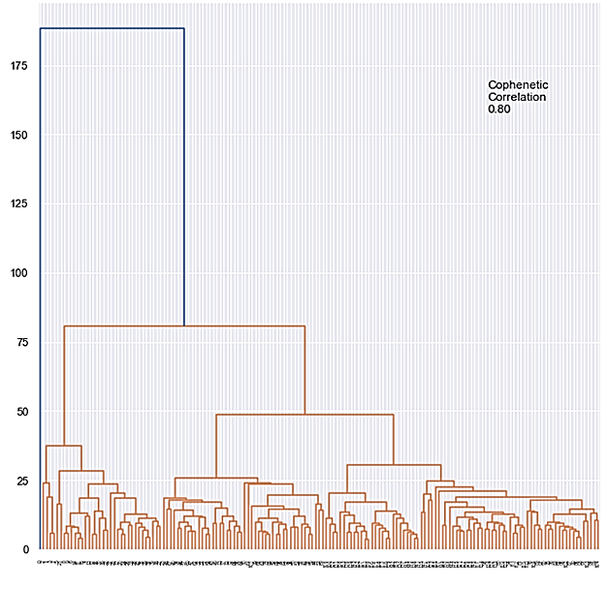

**Figure 4: Graphs of Hierarchical Clustering of 158 Countries.**

It is noticeable that clusters 0, 3, and 4 include developed economies including the United States, Japan, the United Kingdom, Nordic countries, Germany, and France, indicating the developed countries are spending more percentage of GDP than developing and emerging economic countries. Other clusters include many countries from Eastern Europe & Latin America (Cluster 1), Africa and the Caribbean (Cluster 1), and Asia & Middle East (Cluster 5), implying most countries in these regions tend to spend a lower percentage of GDP on healthcare than other developed countries (Figure 6).

**Figure 5: The Number of Countries in Each Cluster.**

**Figure 6: Average Healthcare Expenditures as a Percentage of GDP for Each Cluster.**

**5.1.2 Support Vector Machine (SVM)**

The SVC model, Polynomial SVM, and Gaussian RBF SVM show approximately 77, 71, and 81 percent of accuracy respectively. The graphs of 158 countries are shown in figure 7. United States is in one cluster with high difference with other countries.

The linear SVM shows straight lines between classes, indicating clear linear separations between clusters. However, it might also imply an oversimplification of the relationship between classes.

**Figure 7: Decision Boundary of Linear, Polynomial and Gaussian RBF SVM 0f 2020-2021**

The polynomial SVM shows quite similar, but it has slightly curved boundaries compared to linear boundaries, suggesting the added complexity of the polynomial transformation was unnecessary. The Gaussian model creates more complex and non-linear boundaries with curved and localized decision regions, implying potentially better capacity in capturing the true association between classes. Its superior accuracy to other methods suggests that the data contains patterns such as complicated overlapping classes and non-linearly separable data that can be captured effectively by the Gaussian RBF kernel.

**5.2 Predictive Modeling**

**5.2.1 Autoregression Integrated Moving Average (ARIMA)**

To analyze health expenditure trends across countries, we initially fitted a simple ARIMA model for each country. The ARIMA model was specified with an order of (1, 1, 1), where the parameters represent the following: one lag for the AutoRegressive (AR) term, first-degree differencing (d=1) to address non-stationarity, and one lag for the Moving Average (MA) term. This configuration utilized the value from one step prior for both AR and MA components while assuming stationarity of the time series as a primary requirement for ARIMA models.

However, visual inspection indicated that the data exhibited non-stationary behavior. To address this, we applied first-degree differencing (d=1), ensuring the data met the stationarity assumption. Subsequently, we used the fitted models to predict health expenditure for the next four years, with the results summarized in figure 8, which presents the comprehensive prediction graphs for each country.

To further refine the model and enhance its predictive accuracy, we optimized the ARIMA parameters by leveraging statistical tools. Specifically, we employed the Augmented Dickey-Fuller (ADF) test to assess stationarity and analyzed the Autocorrelation Function (ACF) and Partial Autocorrelation Function (PACF) plots to identify the most parsimonious model for each country. The optimization aimed to minimize the Akaike Information Criterion (AIC) value, a measure of model quality that balances goodness-of-fit with model complexity.

Using this approach, we identified the optimal ARIMA parameters specific to each country, ensuring a tailored model for improved accuracy. The refined models were then fitted to the data, yielding predictions that were both data-driven and statistically robust. These results are discussed in subsequent sections and provide a foundation for analyzing health expenditure trends across different countries.

**5.2.2 Predicted Values**

Table 1 presents the predicted health expenditures for the year 2025 across all selected countries, using both the simple ARIMA model and the enhanced multi-model approach. While the simple ARIMA model demonstrated favorable AIC scores, the multi-model approach achieved further reductions in AIC by fitting ARIMA models with all possible parameter combinations. This optimization led to losing their autoregressive component for most countries, except for Canada, New Zealand, Italy, and Poland.

The differences in predicted expenditures between the two approaches ranged from as little as 0.01 (for Greece) to 0.76 (for the United Kingdom). These results highlight the utility of the multi-model approach in refining parameter selection to enhance predictive accuracy. Figure 9 visualizes the health expenditure of 25 selected countries listed in table 1 in a map.

**5.3 Generative AI**

Generative Adversarial Networks (GANs) play a transformative role in augmenting sparse and underrepresented datasets by generating synthetic yet realistic data. In the context of healthcare expenditure prediction, GANs can create additional data points for countries or regions where reliable data is scarce.

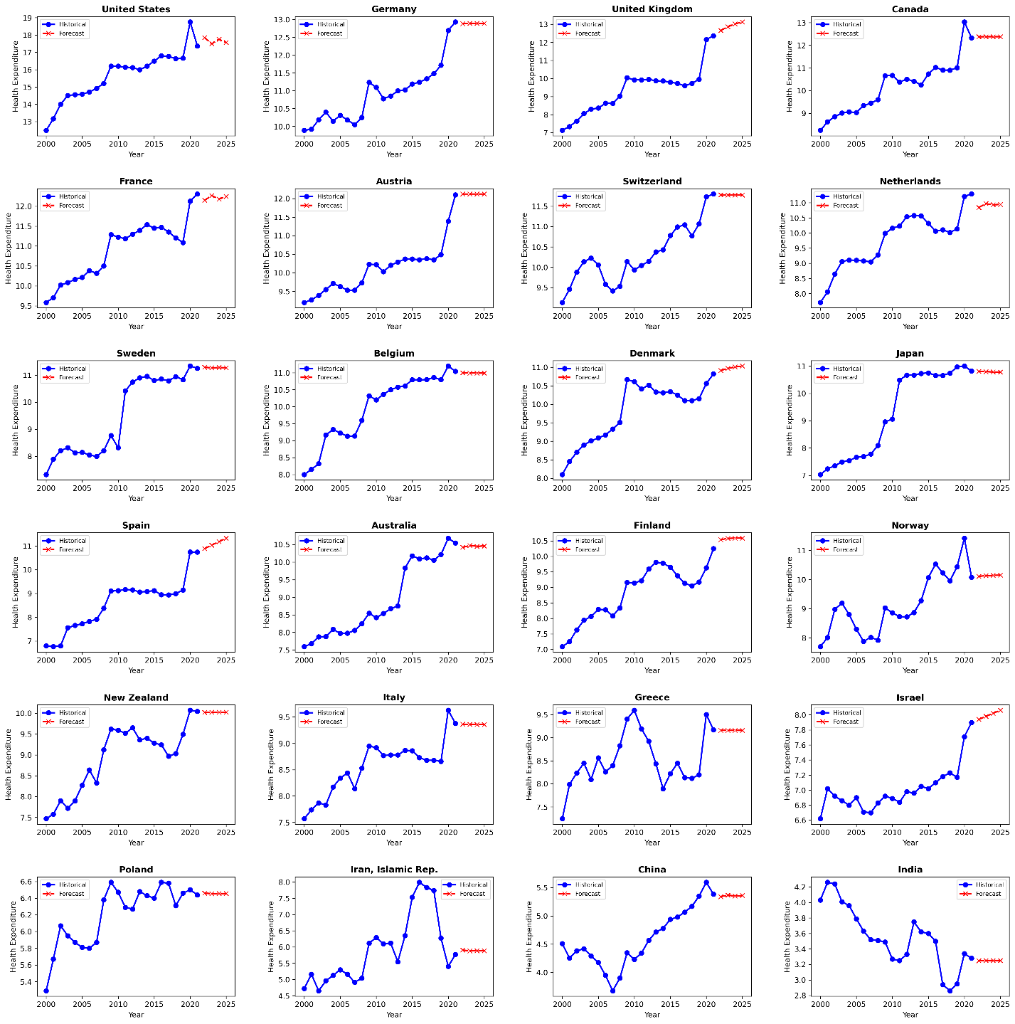

**Figure 8: Predicted Health Expenditure of 2022-2025 with Simple ARIMA Model (p=1, d=1, q=1)**

**Figure 9: Predicted Health Expenditure of 2025 with Simple ARIMA Model (p=1, d=1, q=1)**

|  |  |  |
| --- | --- | --- |
| **Country** | **ARIMA Simple Model** | **ARIMA Multi Model** |
| United States | 17.57 | 17.53 |
| United Kingdom | 13.13 | 12.36 |
| Switzerland | 11.77 | 11.80 |
| Sweden | 11.27 | 11.25 |
| Spain | 11.33 | 10.74 |
| Poland | 6.46 | 6.24 |
| Norway | 10.15 | 10.08 |
| New Zealand | 10.02 | 9.83 |
| Netherlands | 10.95 | 11.29 |
| Japan | 10.78 | 10.82 |
| Italy | 9.36 | 9.09 |
| Israel | 8.06 | 7.90 |
| Iran | 5.88 | 5.77 |
| India | 3.25 | 3.28 |
| Greece | 9.16 | 9.17 |
| Germany | 12.89 | 12.93 |
| France | 12.25 | 12.31 |
| Finland | 10.59 | 10.49 |
| Denmark | 11.03 | 10.82 |
| China | 5.36 | 5.38 |
| Canada | 12.38 | 12.42 |
| Belgium | 10.99 | 11.04 |
| Austria | 12.12 | 12.10 |
| Australia | 10.46 | 10.54 |

**Table 1: Predicted Health Expenditure of 2025 with simple ARIMA model (p=1, d=1, q=1) and multi-model ARIMA with variable parameters for each country**

Figure 10 illustrates the progression of GAN training. The left plot with epoch 0 represents the state before training, where generated data (red points) are scattered randomly, showing no resemblance to the real data (blue points). This highlights the GAN's initial stage of random generation, as the generator has not yet learned the underlying patterns of the real dataset. The latent space dimension and batch size of trained data are 150 and 64 respectively. For the epoch zero discriminator loss (D Loss) is almost 1.396 which shows that the generator makes many errors in classifying real and simulated samples. The generator loss (G Loss) is around 0.783 which means creating fake data.

The right plot with epoch 2000 shows the GAN's capability after extensive training. Here, the generated data aligns closely with the real data, demonstrating the generator's success in learning and replicating the distribution of healthcare expenditure patterns. This alignment indicates the potential of GANs to produce high-quality synthetic data, which can be used to address data sparsity issues in underrepresented regions or time periods. By filling gaps in datasets, GANs enable more accurate predictive modeling and equitable analysis of healthcare expenditures globally. Increasing the number of epochs to 2000 reduces the D and G losses to 0.67 and 0.73 respectively.

|  |  |
| --- | --- |
|  |  |

**Figure 10: Left, Initial GAN Output at Epoch 0. Right, GAN output at Epoch 2000.**

Generative AI brings transformative advantages to healthcare expenditure analysis by addressing limitations of traditional predictive models. One significant benefit is its ability to handle incomplete or imbalanced datasets through data augmentation. By generating synthetic yet realistic data, generative AI fills gaps in underrepresented regions, ensuring that models trained on such data are more inclusive and generalizable. This capability enhances the reliability of global healthcare expenditure predictions, particularly for low-income countries with limited historical data, thus fostering equitable decision-making.

**6. Conclusion**

Despite its transformative potential, implementing generative AI in healthcare expenditure analysis faces significant challenges, particularly related to data quality and privacy. Generative AI models rely heavily on large, high-quality datasets to produce accurate and reliable outputs. However, healthcare expenditure data often suffers from inconsistencies, incomplete records, and regional disparities in reporting. For underrepresented countries or regions with scarce data, the generative model's ability to produce meaningful synthetic data might be compromised. Additionally, concerns around data privacy and compliance with regulations such as GDPR and HIPAA pose obstacles to obtaining and utilizing sensitive healthcare-related information for training models.

Another major challenge is the computational complexity and resource requirements of generative AI models. Training sophisticated models like GANs or VAEs requires substantial computational power, specialized infrastructure, and expertise, which may not be readily available in low-resource settings. Moreover, generative models often lack interpretability, making it difficult for policymakers and stakeholders to fully trust or understand the outputs. The potential for generating unrealistic or biased synthetic data further emphasizes the need for rigorous validation and oversight mechanisms. Overcoming these challenges requires collaboration between AI researchers, policymakers, and healthcare experts to ensure ethical, efficient, and equitable implementation of generative AI solutions.

**References**

[1] Global Medical Trends Survey, 2024.

[2] C. d. Meijer, B. Wouterse, J. Polder, M. Koopmanschap, The effect of population aging on health expenditure growth: a critical review, Eur J Ageing, 10(4): p. 353-361, 2013.

[3] Global Burden of Disease Health Financing Collaborator, Past, present, and future of global health financing: a review of development assistance, government, out-of-pocket, and other private spending on health for 195 countries, 1995-2050. Lancet, 393(10187): p. 2233-2260, 2019.

[4] A. J. Young, R. F. Terry, J. A. Røttingen, R. F. Viergever, Global trends in health research and development expenditures-the challenge of making reliable estimates for international comparison, Health Research Policy and Systems, 13 (1), 2015.

[5] G. Wilensky, H. Gordon, M. D. Sun, D. Jeffrey, D. Steinberg, S. M. Sammut, R. Jagsi, D.Phil, Global Trends in Biomedical R&D. Expenditures. N Engl J Med, 370(1): p. 1-3, 2014.

[6] E. Wager, S. Rakshit, C. Cox, What drives health spending in the U.S. compared to other countries? KFF, Health Cost, 2024.

[7] M. McGough, A. Winger, N. Kurani, C. Cox, How much is health spending expected to grow? KFF, Health Cost, 2024.

[8] A. Glassman, J. M. Keller, E. Smitham, The Future of Global Health Spending Amidst Multiple Crises, Center for Global Development, 2023.

[9] B. H Baltagi, R. Lagravinese, F. Moscone, E. Tosetti, Health Care Expenditure and Income: A Global Perspective. Health Econ. 26(7): p. 863-874, 2017.

[10] A. E. Gascon, J. L. Mico-Sanz, A. C. Ripolles. Global evidence of environmental and lifestyle effects on medical expenditures across 154 countries. Prev Med Rep, 30: p. 102036, 2022.

[11] F. Chen, Z. Chen, Cost of economic growth: Air pollution and health expenditure. Sci Total Environ, 755(Pt 1): p. 142543, 2021.

[12] R. Marley, Top 10 current trends expected to transform healthcare in 2024. Healthcare Transformers, 2024.

[13] M. Bertl, P. Ross, D. Draheim, Systematic AI Support for Decision-Making in the Healthcare Sector: Obstacles and Success Factors. Health Policy and Technology, 12(3), 2023.

[14] P. Doupe, J. Faghmous, S. Basu, Machine Learning for Health Services Researchers. Value Health, 22(7): p. 808-815, 2019.

[15] Langenberger, B., T. Schulte, and O. Groene, The application of machine learning to predict high-cost patients: A performance-comparison of different models using healthcare claims data. PLoS One, 18(1): p. e0279540, 2023.

[16] Z. Obermeyer, E. J. Emanuel, Predicting the Future, Big Data, Machine Learning, and Clinical Medicine. N Engl J Med, 375(13): p. 1212-6, 2016.

[17] J. A. M. Sidey-Gibbons, C. J. Sidey-Gibbons. Machine learning in medicine: a practical introduction. BMC Med Res Methodol, 19(1): p. 64, 2019.

[18] J. R. Khan1, N. Awan, N. Awan, M. Islam. M. Islam, O. Muurlink, Healthcare Capacity, Health Expenditure, and Civil Society as Predictors of COVID-19 Case Fatalities: A Global Analysis. Front Public Health, 8: p. 347, 2020.

[20] I. Mathauer, M. Oranje, 2024 Global Medical Trends. Survey report. Bull World Health Organ, 102(3): p. 216-224, 2024.

[21] B. Nit, A. L. Samy, S. L. Tan, S. Vory, Y. Lim, R. R. Nugraha, X. Lin, A. Ahmadi, D. E. Lucero-Prisno. Understanding the Slow COVID-19 Trajectory of Cambodia. Public health in practice (Oxford, England), 2, 100073, 2021.

[22] H. Boulhol, A. Sowa, S. Golinowska, P. Sicari, Improving the Health-Care System in Poland, OECD Economics Department Working Papers, No. 957, OECD, 2012.

1. https://data.worldbank.org/indicator/SH.XPD.CHEX.GD.ZS?most_recent_year_desc=true&locations=1W